**Assignment No : 3**

**Title : Feedback and Constraints (Internet).**

**Feedbacks**



**Source –** Google Images

**Feedback –** The PS controller has a mechanism of Haptic feedback that indicates that a rough action is taking place in game.



**Source –** Google Images

**Feedback –** When the light on the taxi is turned on then it indicates that it is available for service else it is taken.



**Source –** Google Images

**Feedback –** The payment sound of UPI Indicates that the payment is successfully completed.

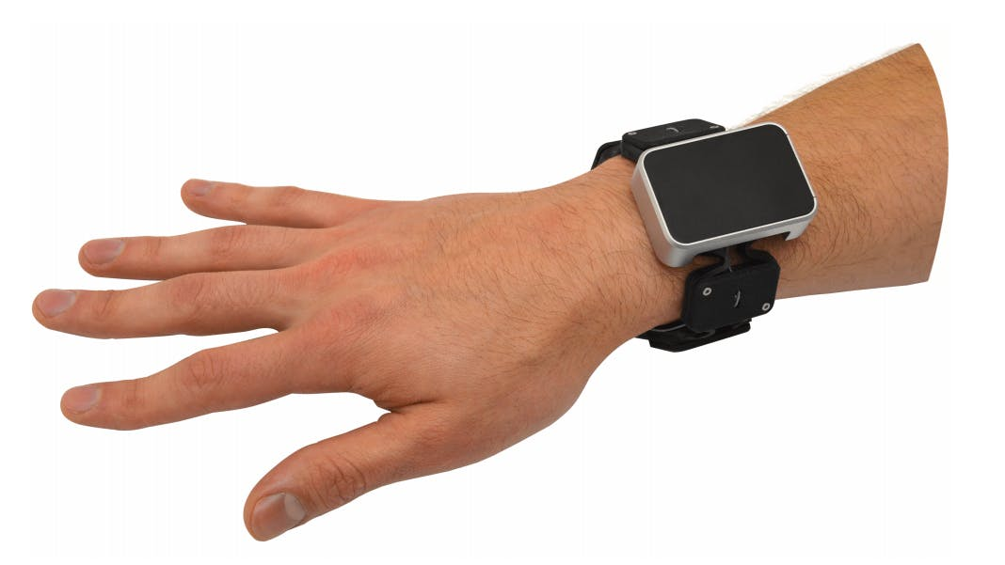

**Source –** Google Images

**Feedback –** The vibration of smart watch indicates that a notification is received.

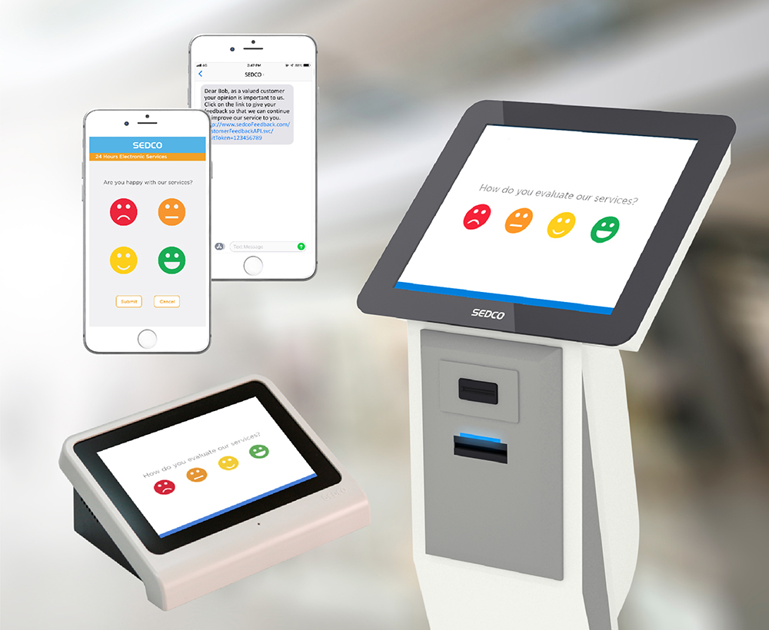

**Source –** Google Images

**Feedback –** The feedback machine can be used to give feedback to the company about their service.

**Constraints**



**Source –** Google Images

**Constraint –** The plastic cover prevents anyone from opening the packet without buying it.



**Source –** Google Images

**Constraint –** The signal prevents/allows us to pass or stop depending on the symbol and color it shows.

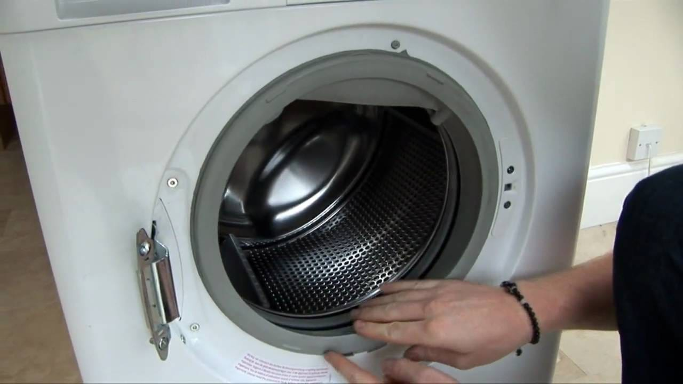

**Source –** Google Images

**Constraint –** The Transparent lid prevents the water from coming out after putting in the cloths for washing.

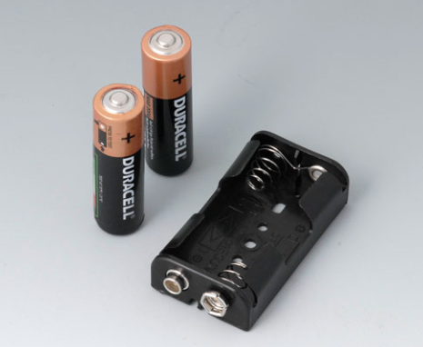

**Source –** Google Images

**Constraint –** The springs prevent the cell from sliding out after placing them.

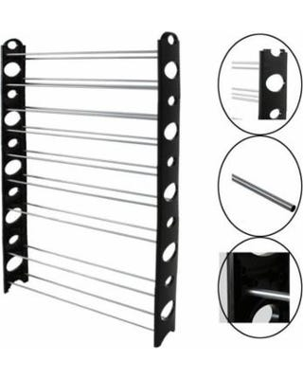

**Source –** Google Images

**Constraint –** The rods of the shelf can be adjusted and can be stuck in the holes so they won’t move.